Lab 11.2 – Maximo A.

Refer to Chapter 9: Getting Started with JavaScript

Add a screenshot of the source code of the **tny_script.js file** after completing Step 2 on page HTML 714

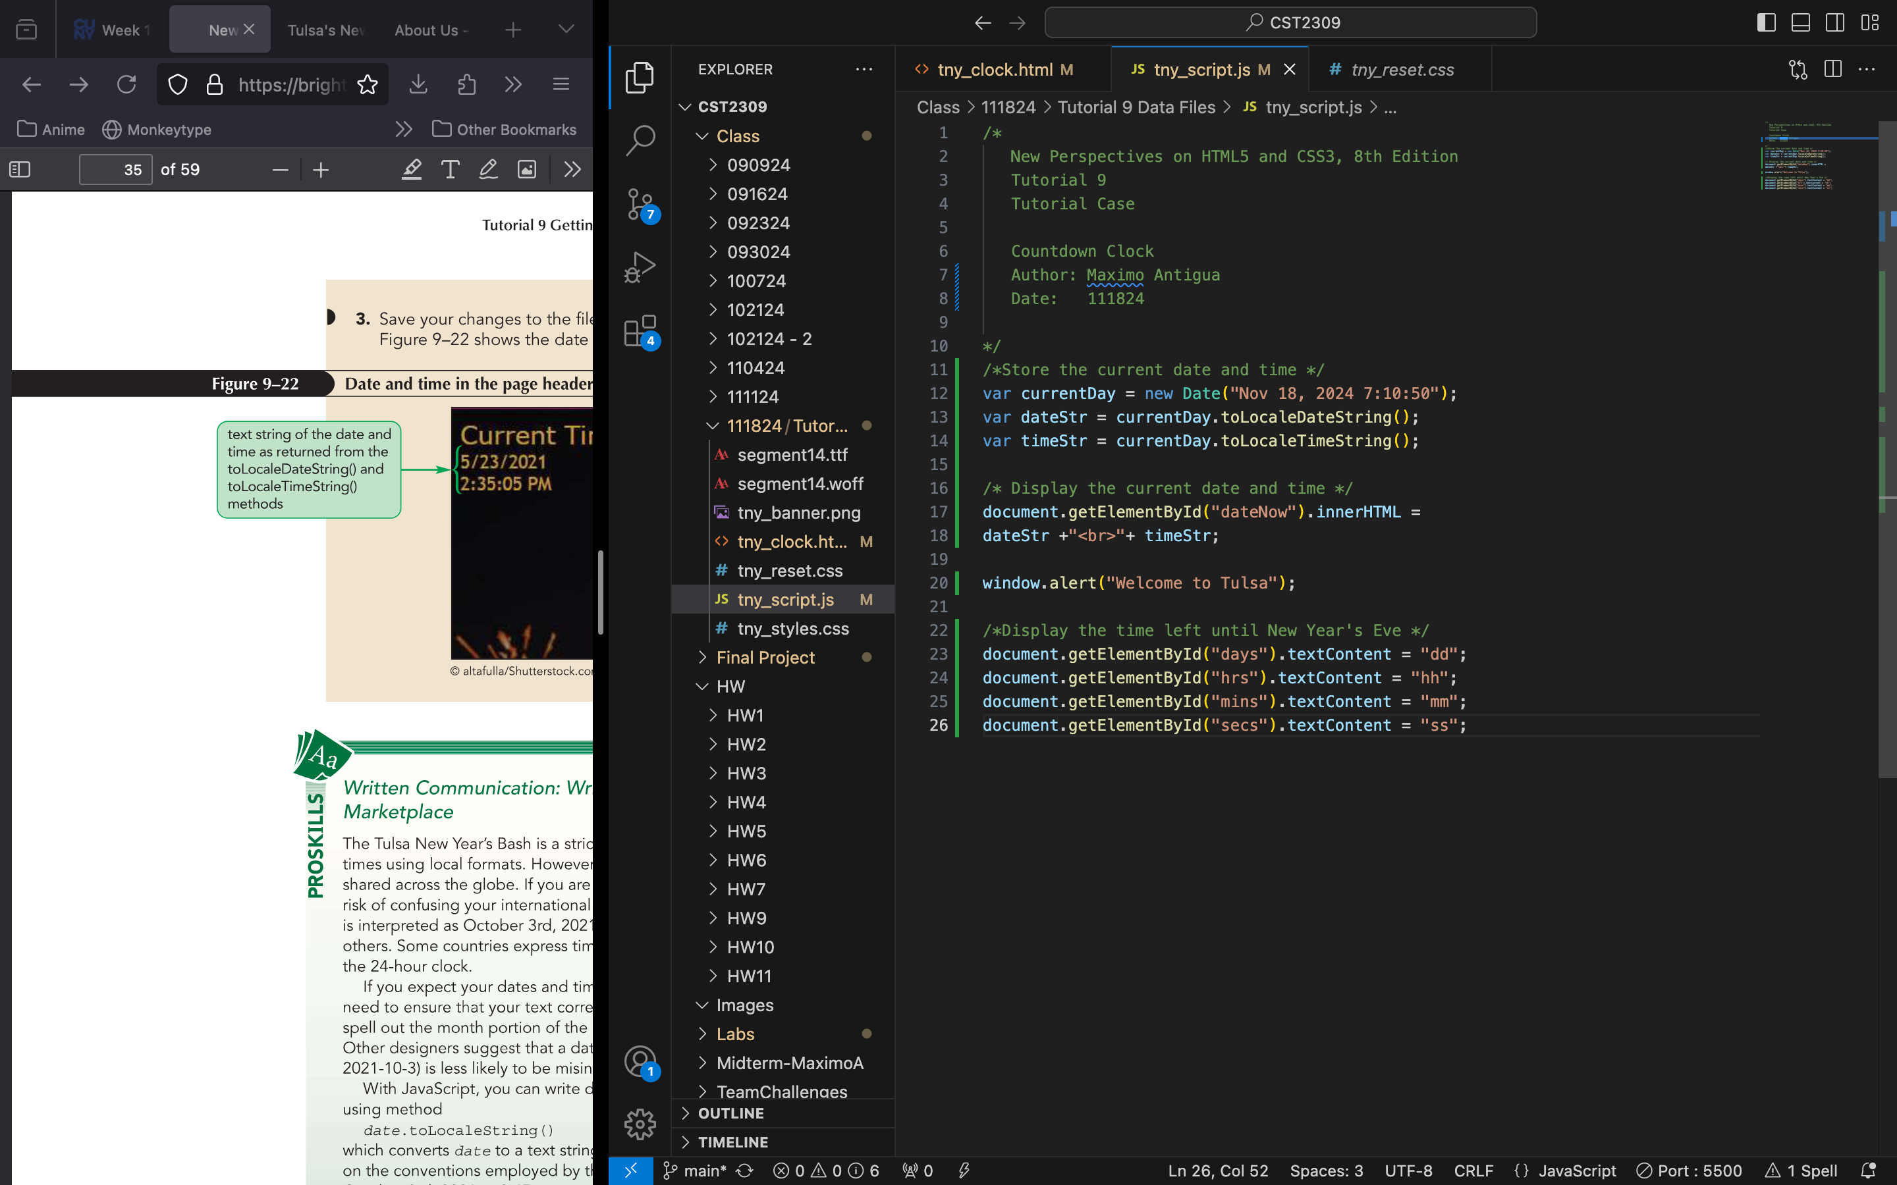

Add a screenshot of the **tny_clock.html file** displayed in your web browser after completing Step 3 on page HTML 715. Include the browser address bar. Show the Current Date and Time , and the countdown clock text generated by JavaScript using the textContent propertyas shown in Figure 9-18

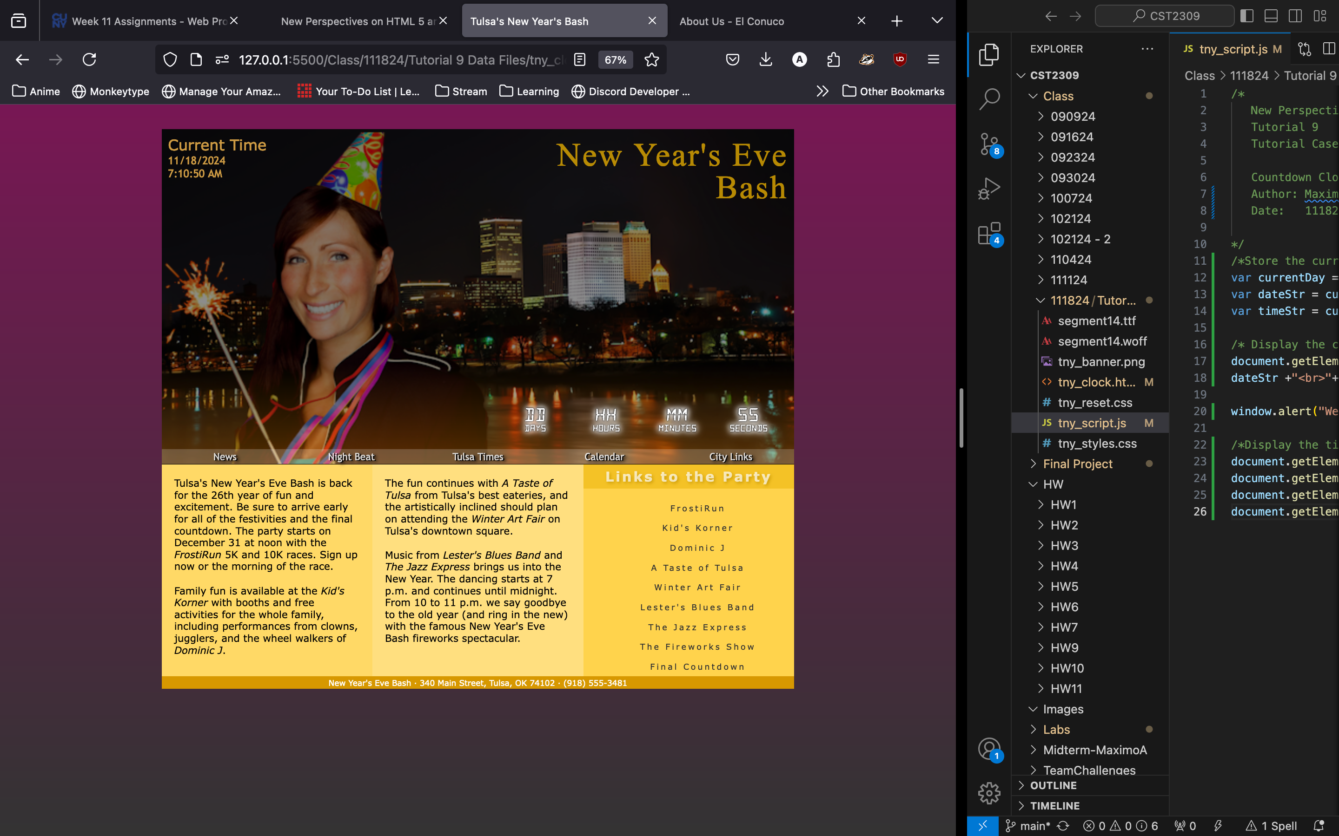

Answer the following questions: Enter a, b, c or d in the shaded area

d

a

c

a